

**How to install the Prometheus and Granfana on Ubuntu Virtual machine 220**

**Installation on Prometheus for Ubuntu 22.4.0**

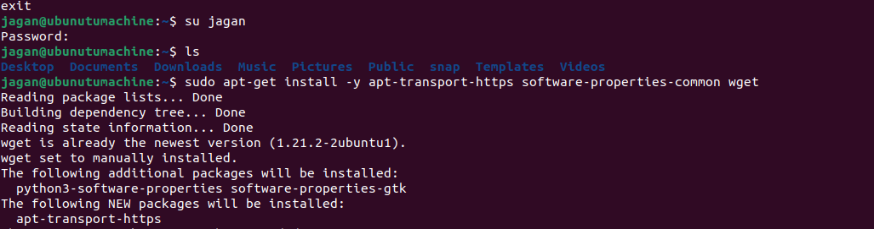

**Step 1: Update the Package Repository**

sudo apt update

**Step 2: Create the usergroup and the user to that group**

sudo groupadd --system prometheus

sudo useradd -s /sbin/nologin --system -g prometheus prometheus

**Installation on Grafana Document :**

### **Step 3 - Create Directories for Prometheus**

sudo mkdir /etc/prometheus  
sudo mkdir /var/lib/prometheus

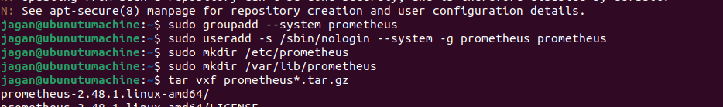

**Step 4: Download the file s**

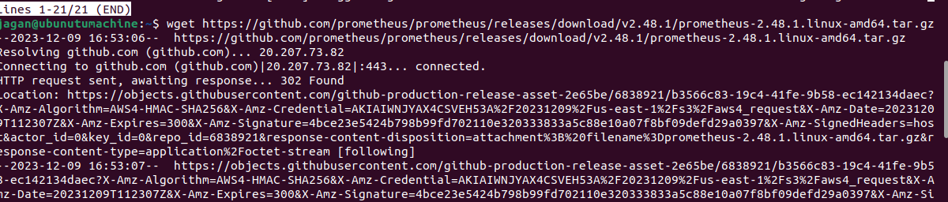

tar vxf prometheus*.tar.gz

**Step 5- Navigate to the Prometheus Directory**

cd prometheus*/

**Step 6 - Move the Binary Files & Set Owner**

sudo mv prometheus /usr/local/bin  
sudo mv promtool /usr/local/bin  
sudo chown prometheus:prometheus /usr/local/bin/prometheus  
sudo chown prometheus:prometheus /usr/local/bin/promtool

### **Step 2 - Move the Configuration Files & Set Owner**

sudo mv consoles /etc/prometheus  
sudo mv console_libraries /etc/prometheus  
sudo mv prometheus.yml /etc/prometheus

sudo chown prometheus:prometheus /etc/prometheus  
sudo chown -R prometheus:prometheus /etc/prometheus/consoles  
sudo chown -R prometheus:prometheus /etc/prometheus/console_libraries  
sudo chown -R prometheus:prometheus /var/lib/prometheus

---No Change was required and just verify the prometheus.yml

sudo nano /etc/prometheus/prometheus.yml

### **Step 2 - Create Prometheus Systemd Service**

sudo nano /etc/systemd/system/prometheus.service

Please add the entry on this prometheus.service

[Unit]  
Description=Prometheus  
Wants=network-online.target  
After=network-online.target  
  
[Service]  
User=prometheus  
Group=prometheus  
Type=simple  
ExecStart=/usr/local/bin/prometheus \  
 --config.file /etc/prometheus/prometheus.yml \  
 --storage.tsdb.path /var/lib/prometheus/ \  
 --web.console.templates=/etc/prometheus/consoles \  
 --web.console.libraries=/etc/prometheus/console_libraries  
  
[Install]  
WantedBy=multi-user.target

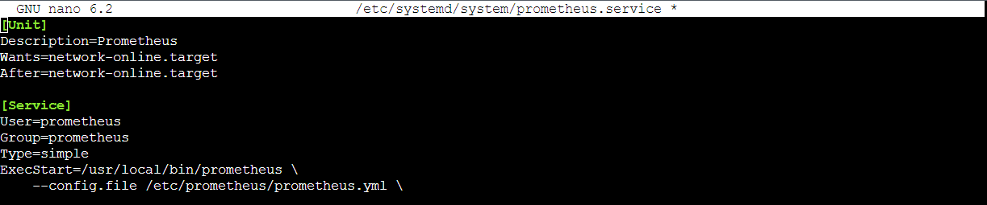

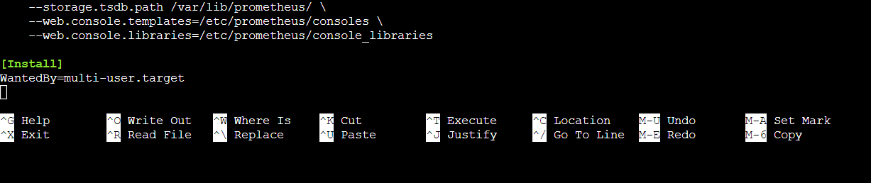

### **Step 3 - Reload Systemd**

sudo systemctl daemon-reload

### **Step 4 - Start Prometheus Service**

sudo systemctl enable prometheus  
sudo systemctl start prometheus

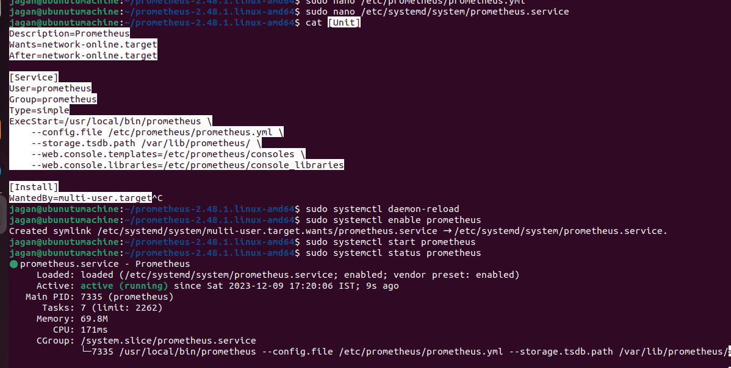

Step 5:

### **Step 5 - Check Prometheus Status**

sudo systemctl status prometheus

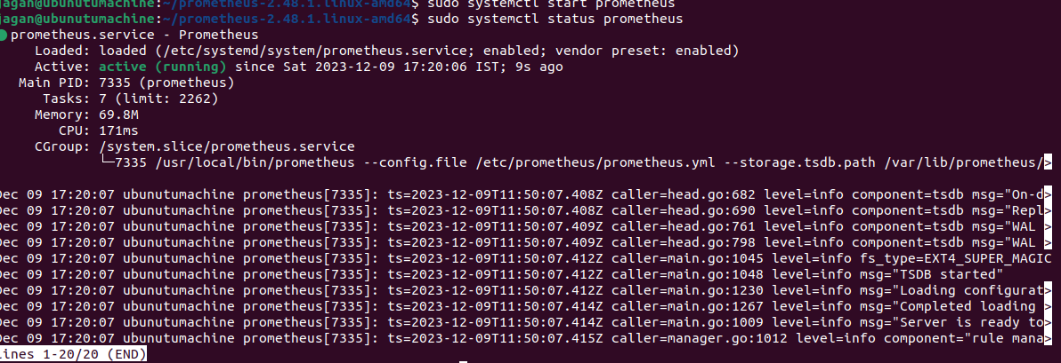

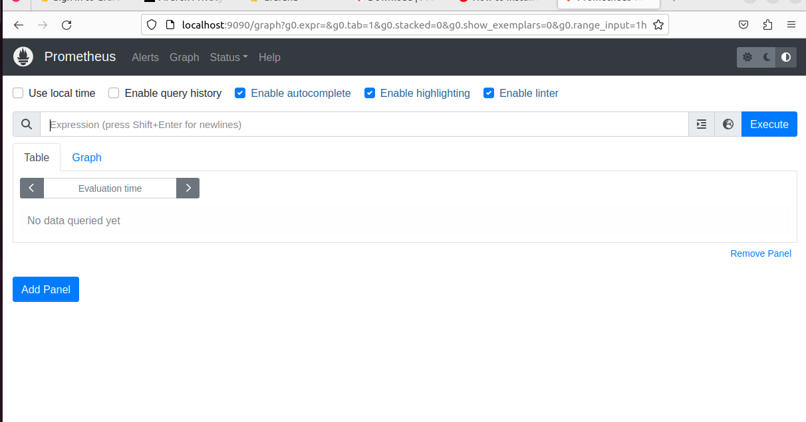

Completion of Prometheus server

Step 1: Installation on Grafana for ubuntu machine

[Install Grafana on Debian or Ubuntu | Graf](https://grafana.com/docs/grafana/latest/setup-grafana/installation/debian/) ana documentation

Step 2: Run this command on ubunutu machine :[Start the Grafana server | Grafana documentation](https://grafana.com/docs/grafana/latest/setup-grafana/start-restart-grafana/)

sudo apt-get install -y apt-transport-https software-properties-common wget

sudo mkdir -p /etc/apt/keyrings/

wget -q -O - https://apt.grafana.com/gpg.key | gpg --dearmor | sudo tee /etc/apt/keyrings/grafana.gpg > /dev/null

echo "deb [signed-by=/etc/apt/keyrings/grafana.gpg] https://apt.grafana.com stable main" | sudo tee -a /etc/apt/sources.list.d/grafana.list

echo "deb [signed-by=/etc/apt/keyrings/grafana.gpg] https://apt.grafana.com beta main" | sudo tee -a /etc/apt/sources.list.d/grafana.list

# Updates the list of available packages

sudo apt-get update

# Installs the latest OSS release:

sudo apt-get install grafana

To start the service, run the following commands:

sudo systemctl daemon-reload

sudo systemctl start grafana-server

sudo systemctl status grafana-server

sudo systemctl status grafana-server

Uninstall the Granfana Server:

sudo apt-get remove grafana

sudo apt-get remove --auto-remove grafana

